**Name :** Dhavalkumar Vijaykumar Patel

**Subject :** Essential of Cyber Security and Cyber Waefare

**Class :** M.Sc Cyber Security

**Semester :** 1

**Lab – 2**

**Practical's related to**

**Service Packs, Hotfixes, and Backups: Service packs Email security bulletins, Patch**

**installation, Automatic updates, Windows server update services, Windows**

**backup, System restore, Device driver rollback. Windows Access Controls, NTFS**

**Permissions, Shared Folder Permissions,**

**Service Packs:**

A service pack is a Windows update, often combining previously released updates, that helps make Windows more reliable. Service packs can include **security and performance improvements and support for new types of hardware**. Make sure you install the latest service pack to help keep Windows up to date.

a service pack comprises a collection of updates, fixes, or enhancements to a software program delivered in the form of a single installable package. Companies often release a service pack when the number of individual patches to a given program reaches a certain (arbitrary) limit, or the software release has shown to be stabilized with a limited number of remaining issues based on users' feedback and bug reports. In large software applications such as office suites, operating systems, database software, or network management, it is not uncommon to have a service pack issued within the first year or two of a product's release. Installing a service pack is easier and less error-prone than installing many individual patches, even more so when updating multiple computers over a network, where service packs are common.

**Hotfixes:**

The term "hotfix" originally referred to software patches that were applied to "hot" systems: those which are live, currently running, and in production status rather than development status. For the developer, a hotfix implies that the change may have been made quickly and outside normal development and testing processes. This could increase the cost of the fix by requiring rapid development, overtime or other urgent measures. For the user, the hotfix could be considered riskier or less likely to resolve the problem. This could cause an immediate loss of services, so depending on the severity of the bug, it may be desirable to delay a hotfix. The risk of applying the hotfix must be weighed against the risk of not applying it, because the problem to be fixed might be so critical that it could be considered more important than a potential loss of service

**Backup:**

a backup, or data backup is a copy of computer data taken and stored elsewhere so that it may be used to restore the original after a data loss event. The verb form, referring to the process of doing so, is "back up", whereas the noun and adjective form is "backup".[1] Backups can be used to recover data after its loss from data deletion or corruption, or to recover data from an earlier time. [2] Backups provide a simple form of disaster recovery; however not all backup systems are able to reconstitute a computer system or other complex configuration such as a computer cluster, active directory server, or database server

**Service packs**

A service pack is a Windows update, often combining previously released updates, that helps make Windows more reliable. Service packs can include security and performance improvements and support for new types of hardware. Make sure you install the latest service pack to help keep Windows up to date.

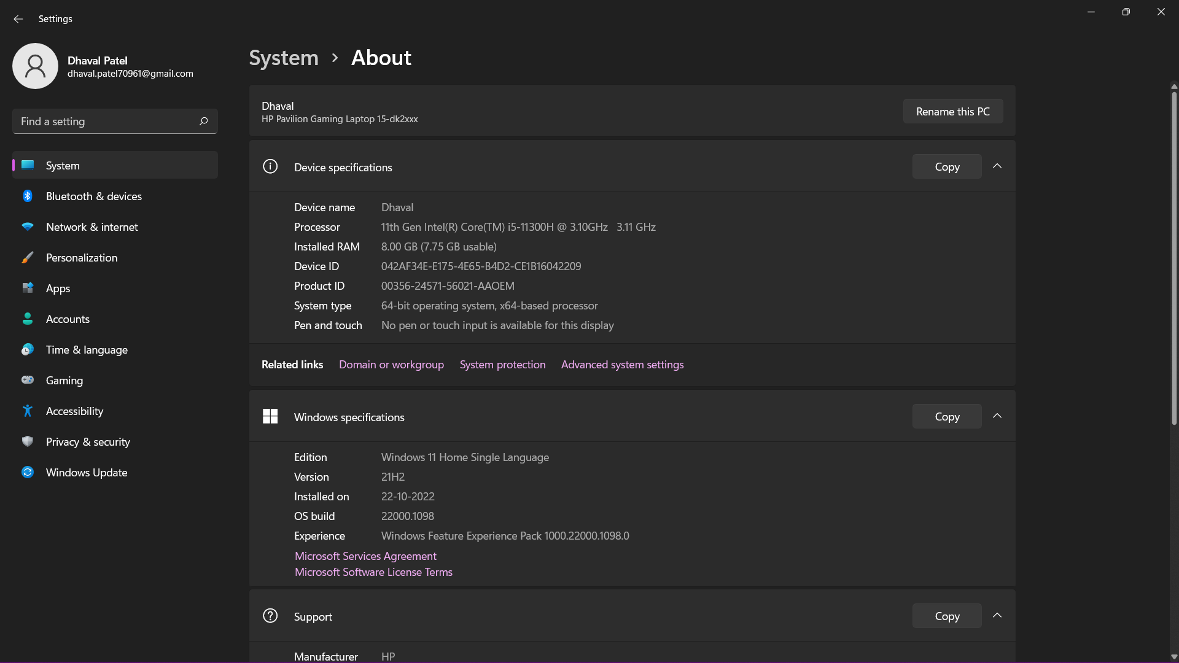

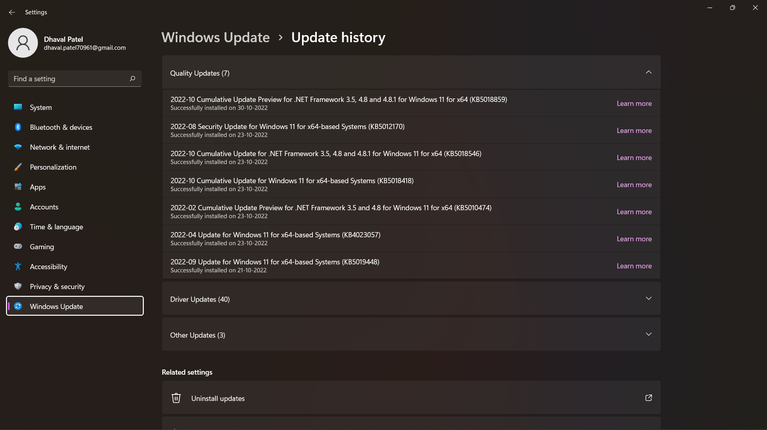

**Email security bulletins**

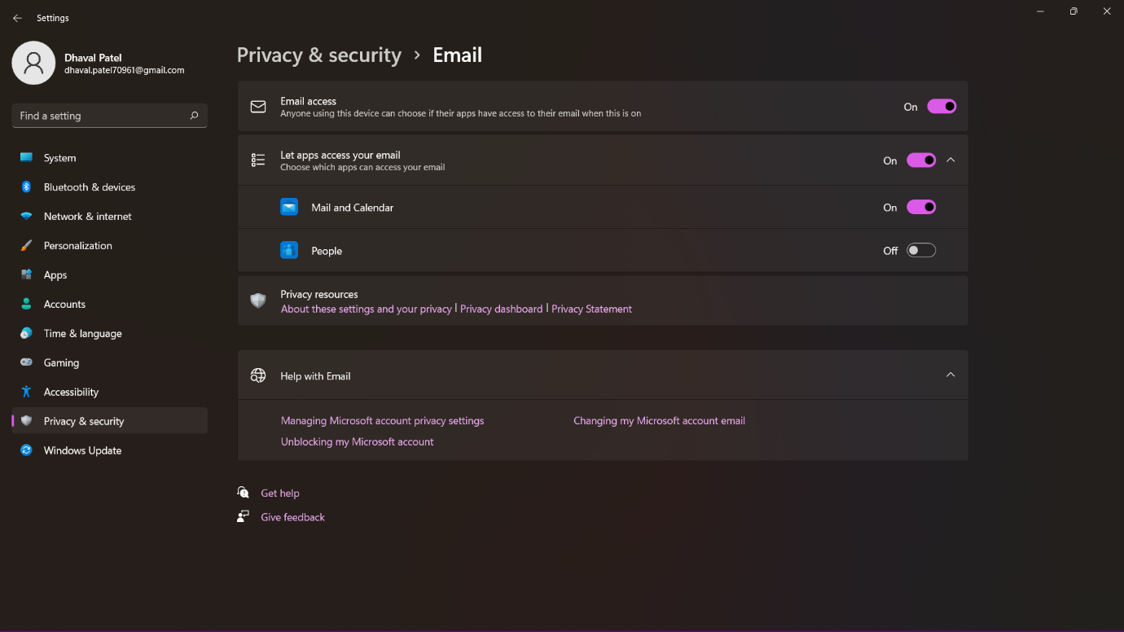

**Patch Intallation:**

A patch is a set of changes to a computer program or its supporting data designed to update, fix, or improve it.[1] This includes fixing security vulnerabilities[1] and other bugs, with such patches usually being called bugfixes or bug fixes.[2][better source needed] Patches are often written to improve the functionality, usability, or performance of a program. The majority of patches are provided by software vendors for operating system and application updates.

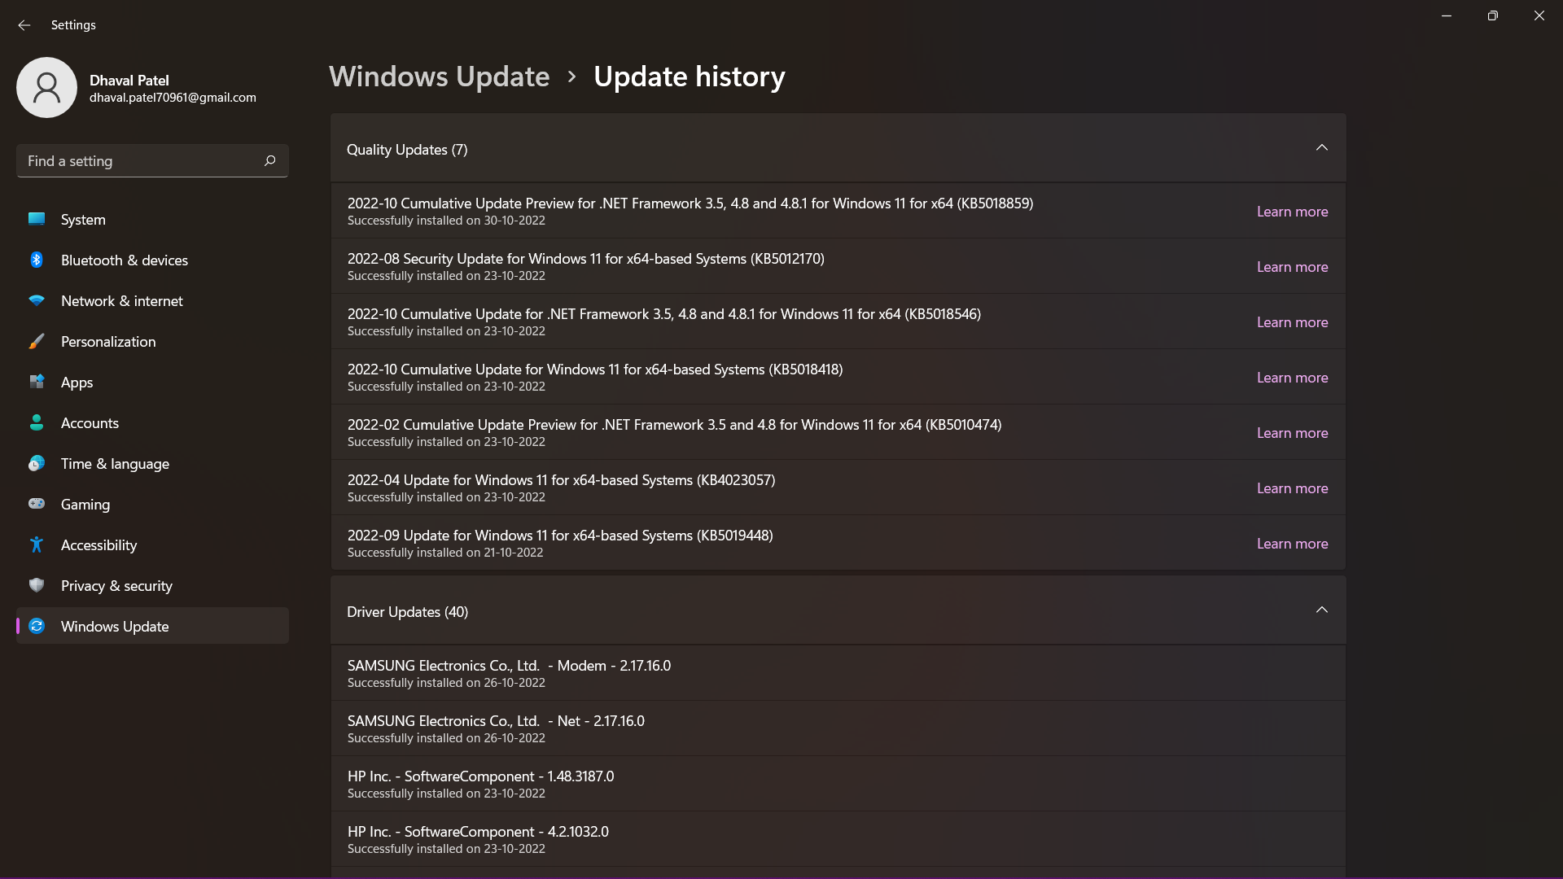

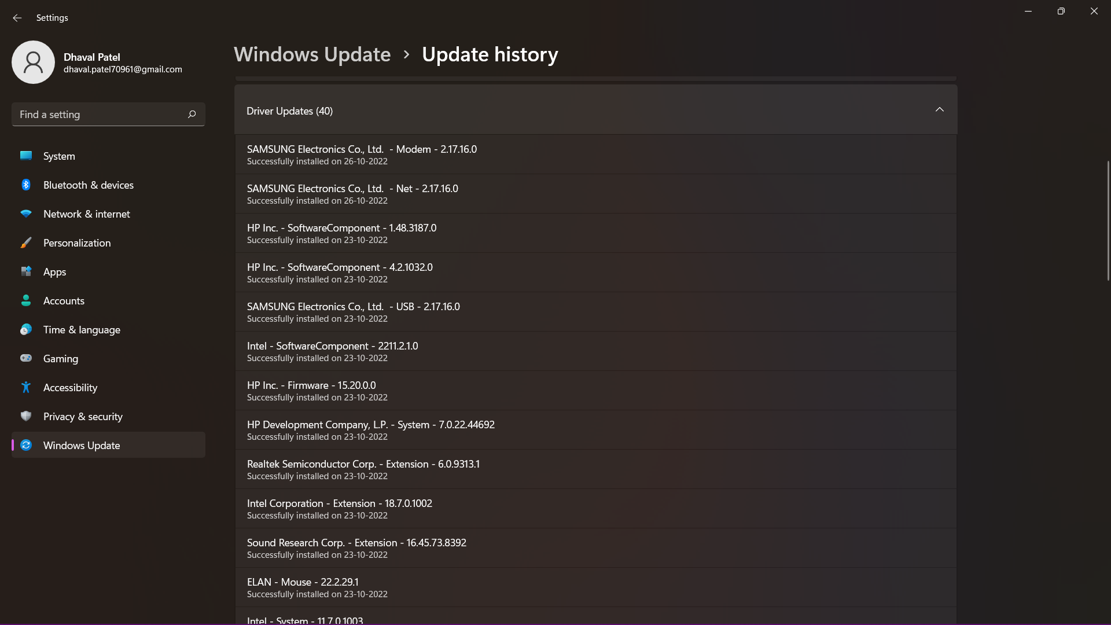

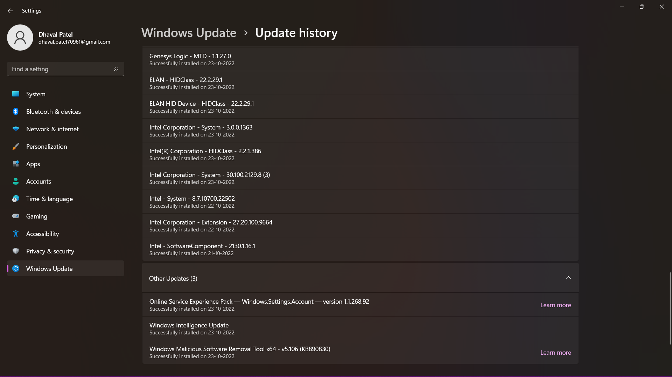

**Automatic updates**

With the Automatic Updates feature, Windows can automatically keep the computer up to date with the latest updates and enhancements. You no longer have to search for critical updates and information; Windows delivers them directly to the computer

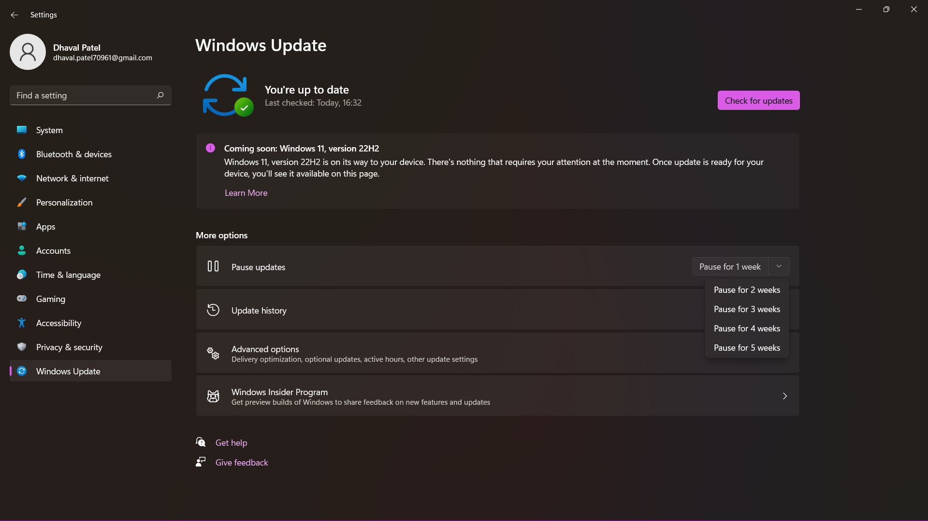

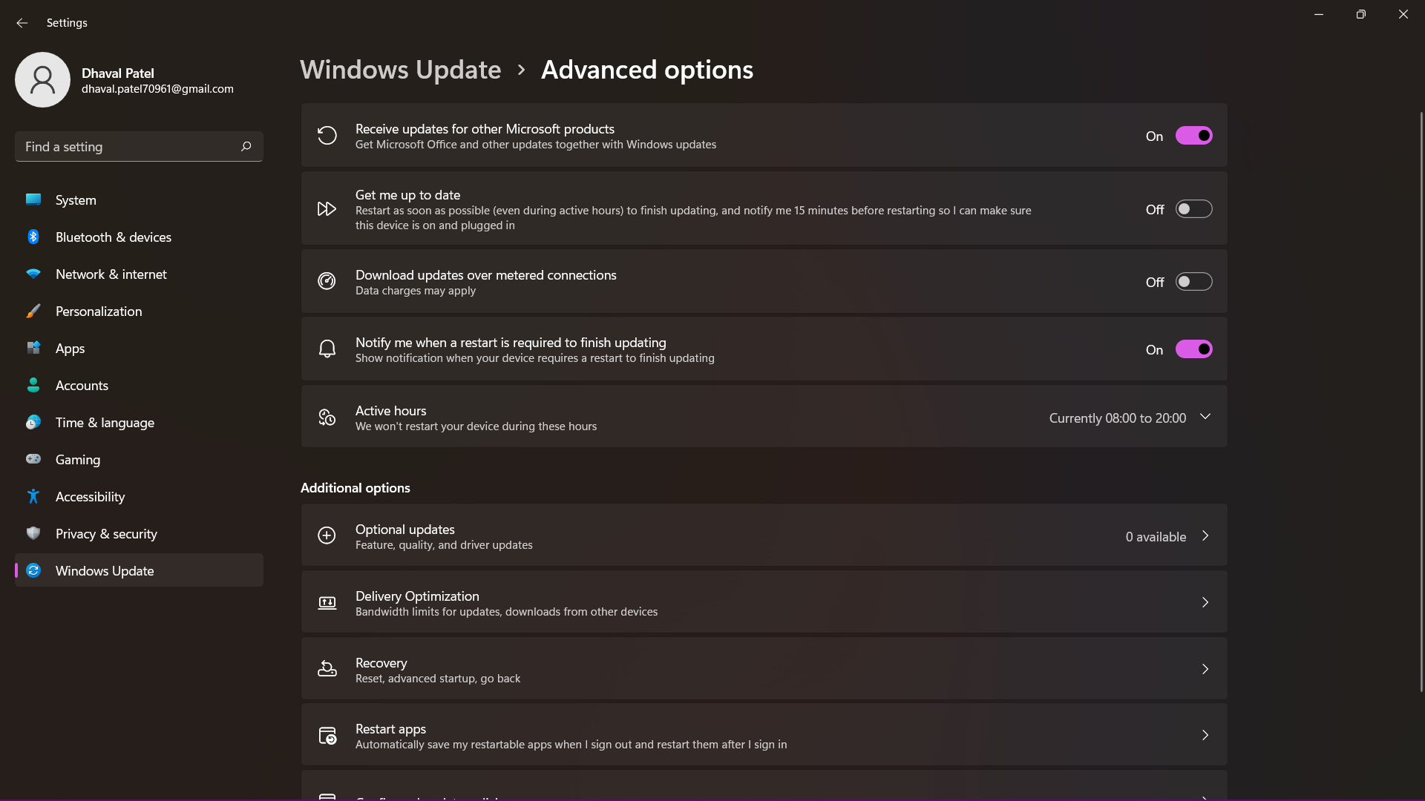

**Windows server update service:**

Windows Server Update Services (WSUS), previously known as Software Update Services (SUS), is a computer program and network service developed by Microsoft Corporation that enables administrators to manage the distribution of updates and hotfixes released for Microsoft products to computers in a corporate environment. WSUS downloads these updates from the Microsoft Update website and then distributes them to computers on a network. WSUS is an integral component of Windows Server.

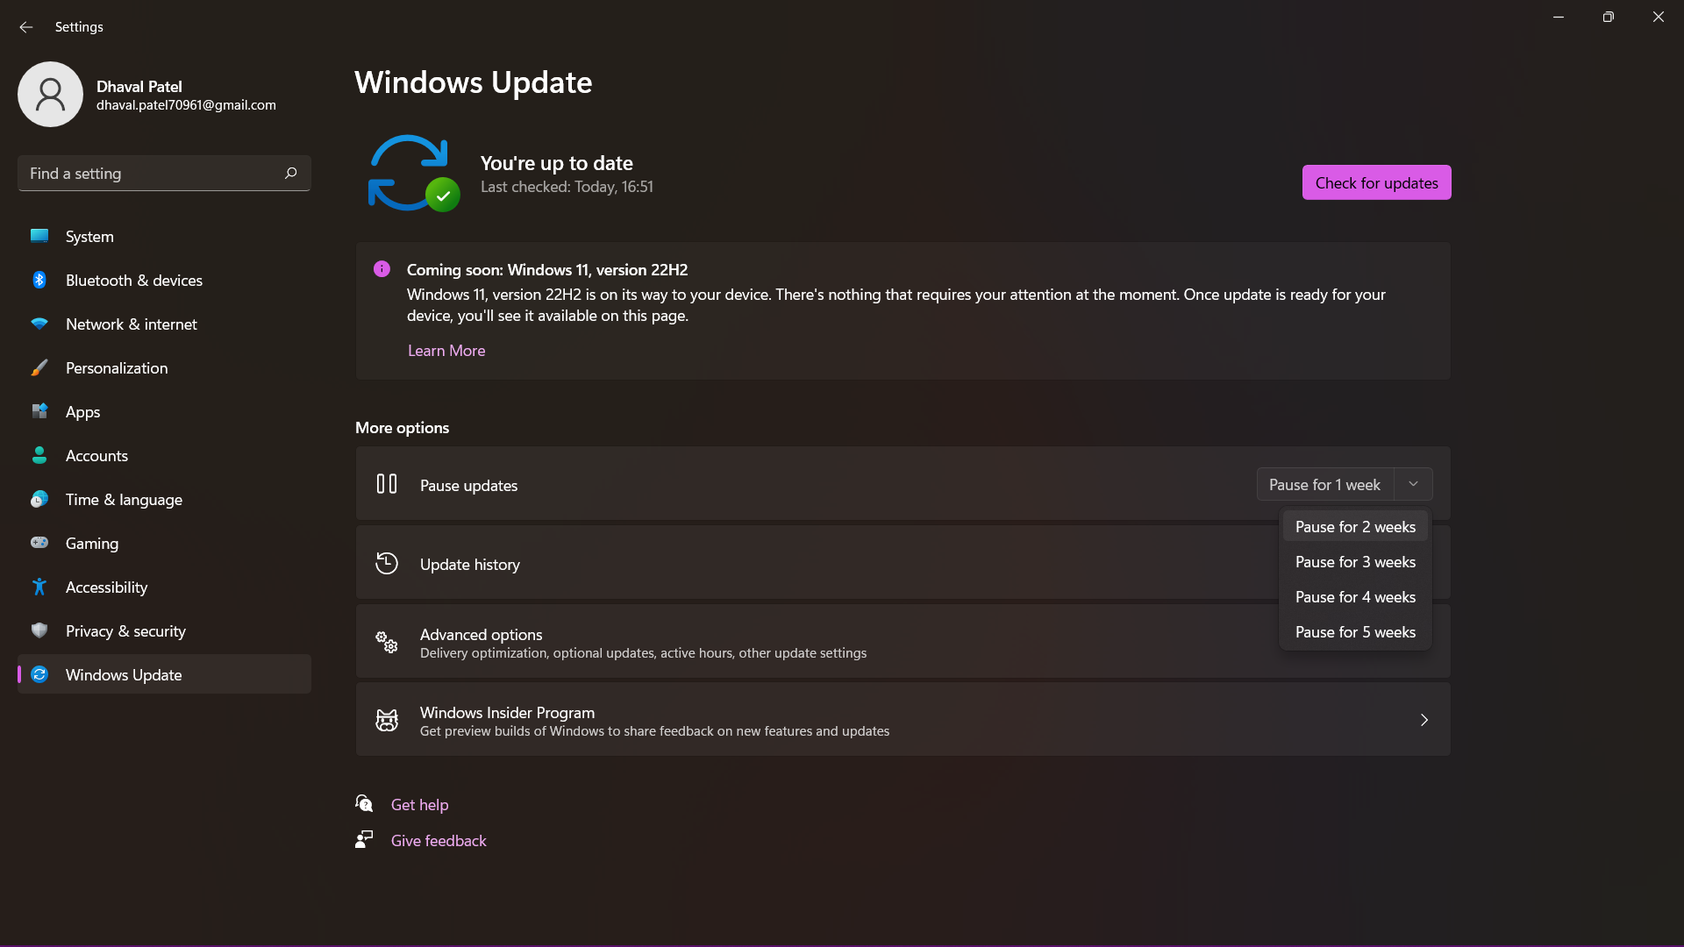

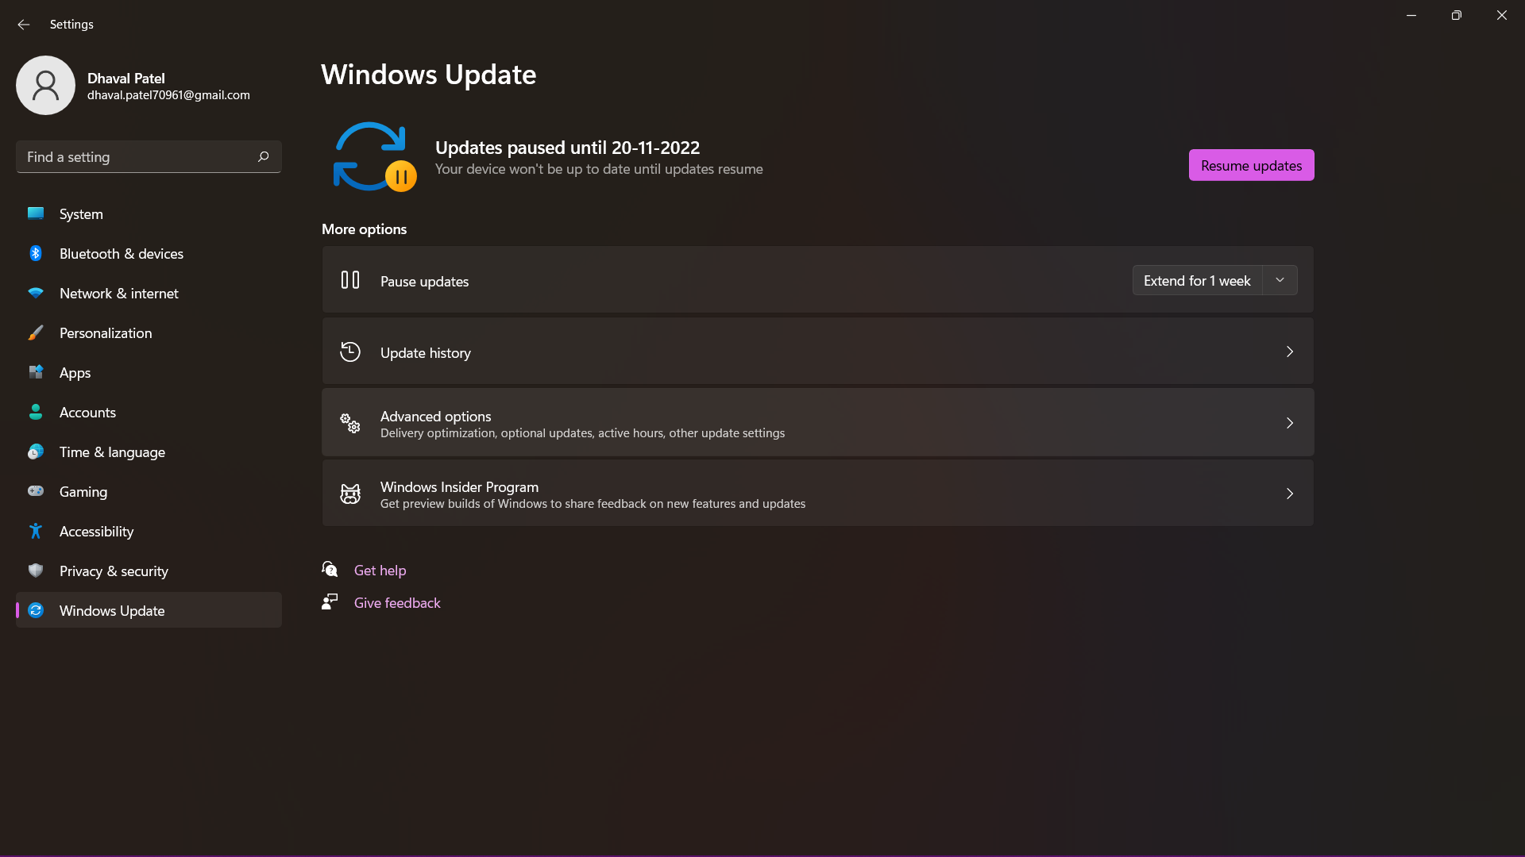

**Windows backup :**

Backup is the process of creating a copy of the data on your system that you use for recovery in case your original data is lost or corrupted. You can also use backup to recover copies of older files if you have deleted them from your system

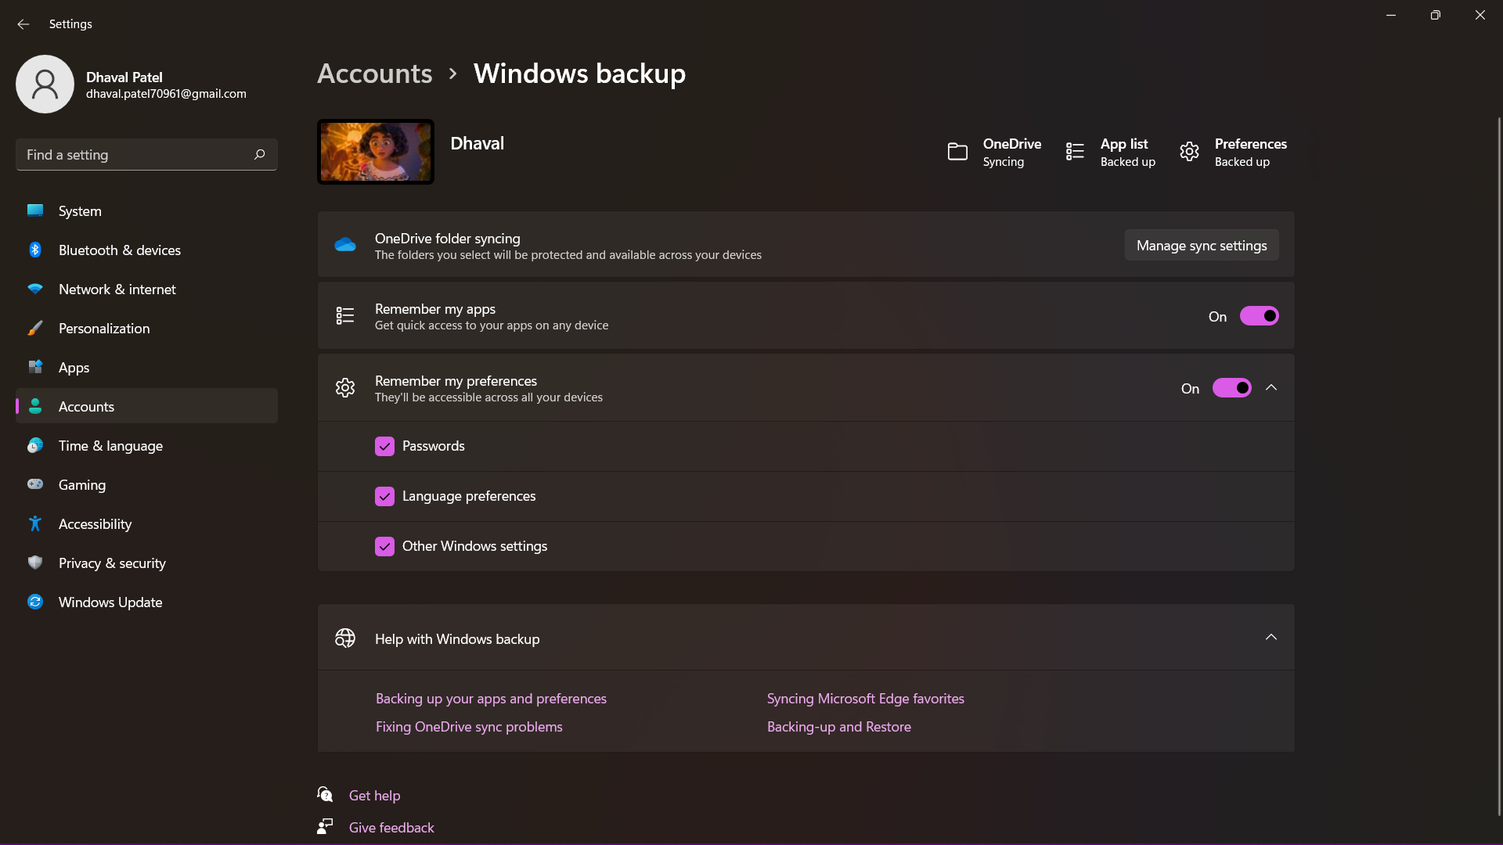

**Creating back up :**

Go to **Control pannal > Backup and Restore > set backup**

**Select a drive where you want to save your back up**

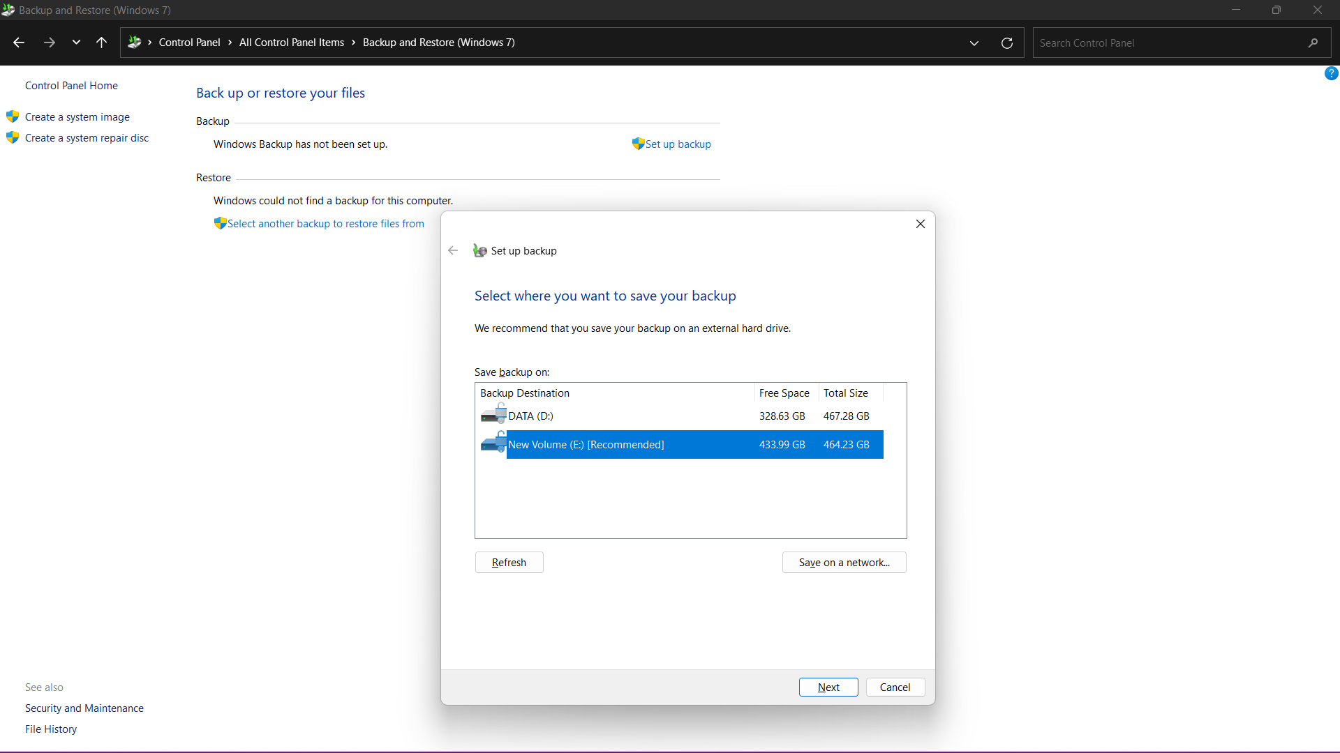

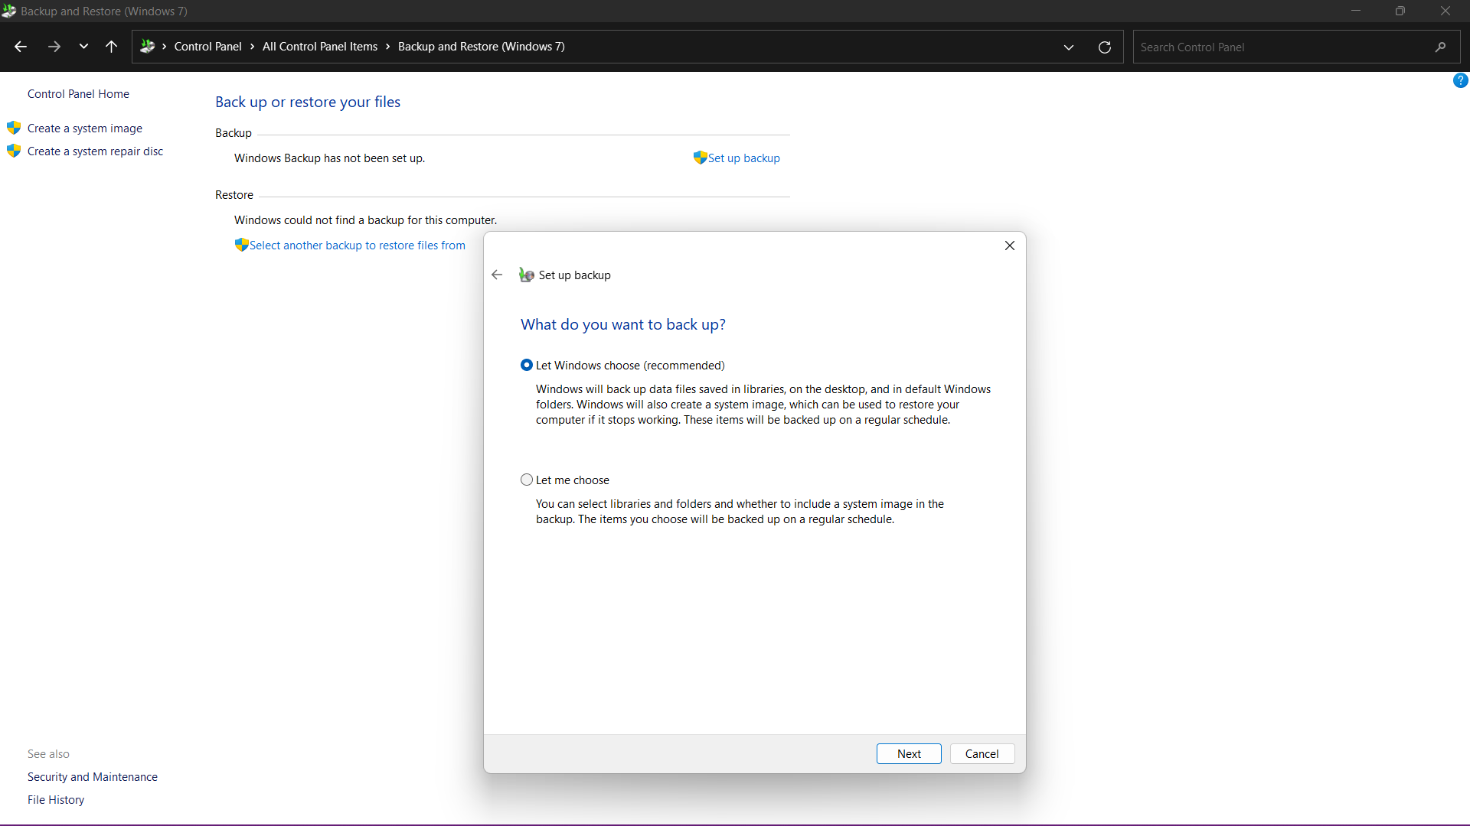

**Click > SAVE SETTING and RUN BACKUP**

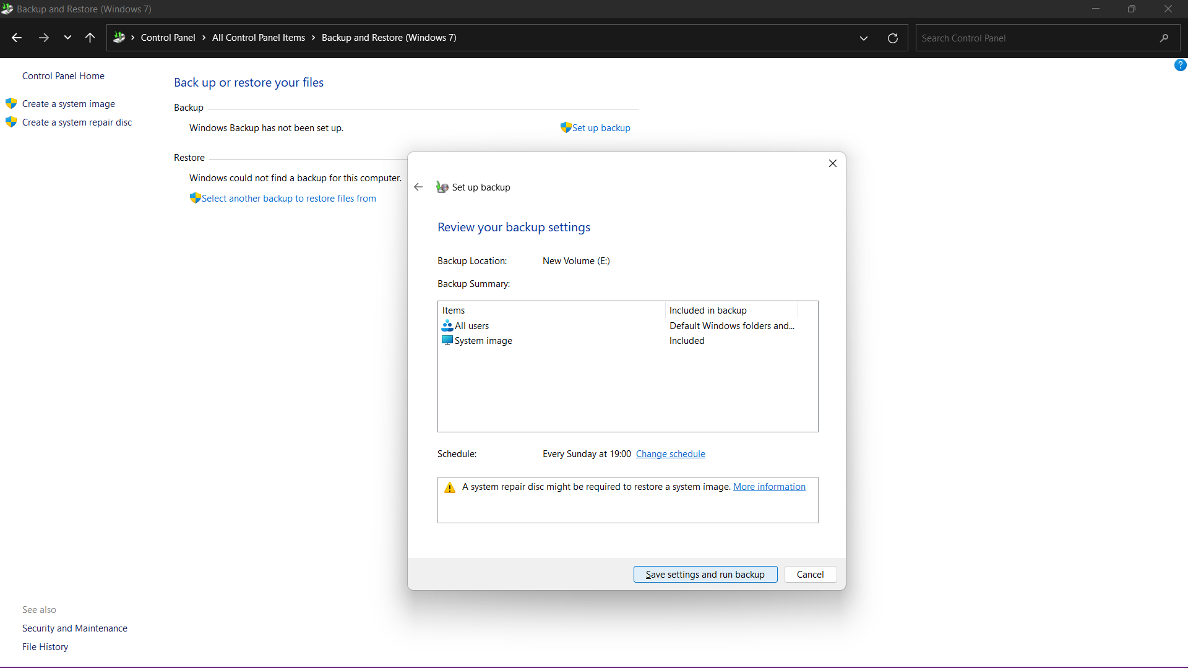

**SYSTEM RESTORE:**

System Restore takes a "snapshot" of the some system files and the Windows registry and saves them as Restore Points. When an install failure or data corruption occurs, System Restore can return a system to working condition without you having to reinstall the operating system.

**RESTORE BACKUP:**

Go to **Control pannal > Backup and Restore > select another backup to restore file from**

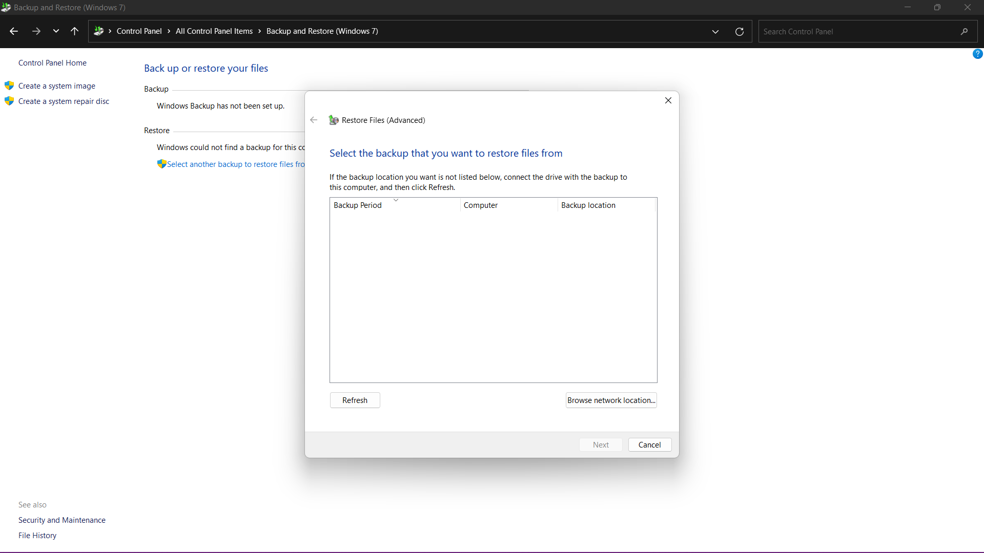

**Device driver rollback**

Driver rollback feature in Microsoft Windows helps restore the device driver to a previous version. This helps avoid potential conflicts or issues with the new driver that is installed on the computer

Go to

**DEVICE MANGER > SELECT THE DEVICE YOU WANT TO ROOLBAK > SELECT DRIVER TAB > ROLLBACK DRIVER**

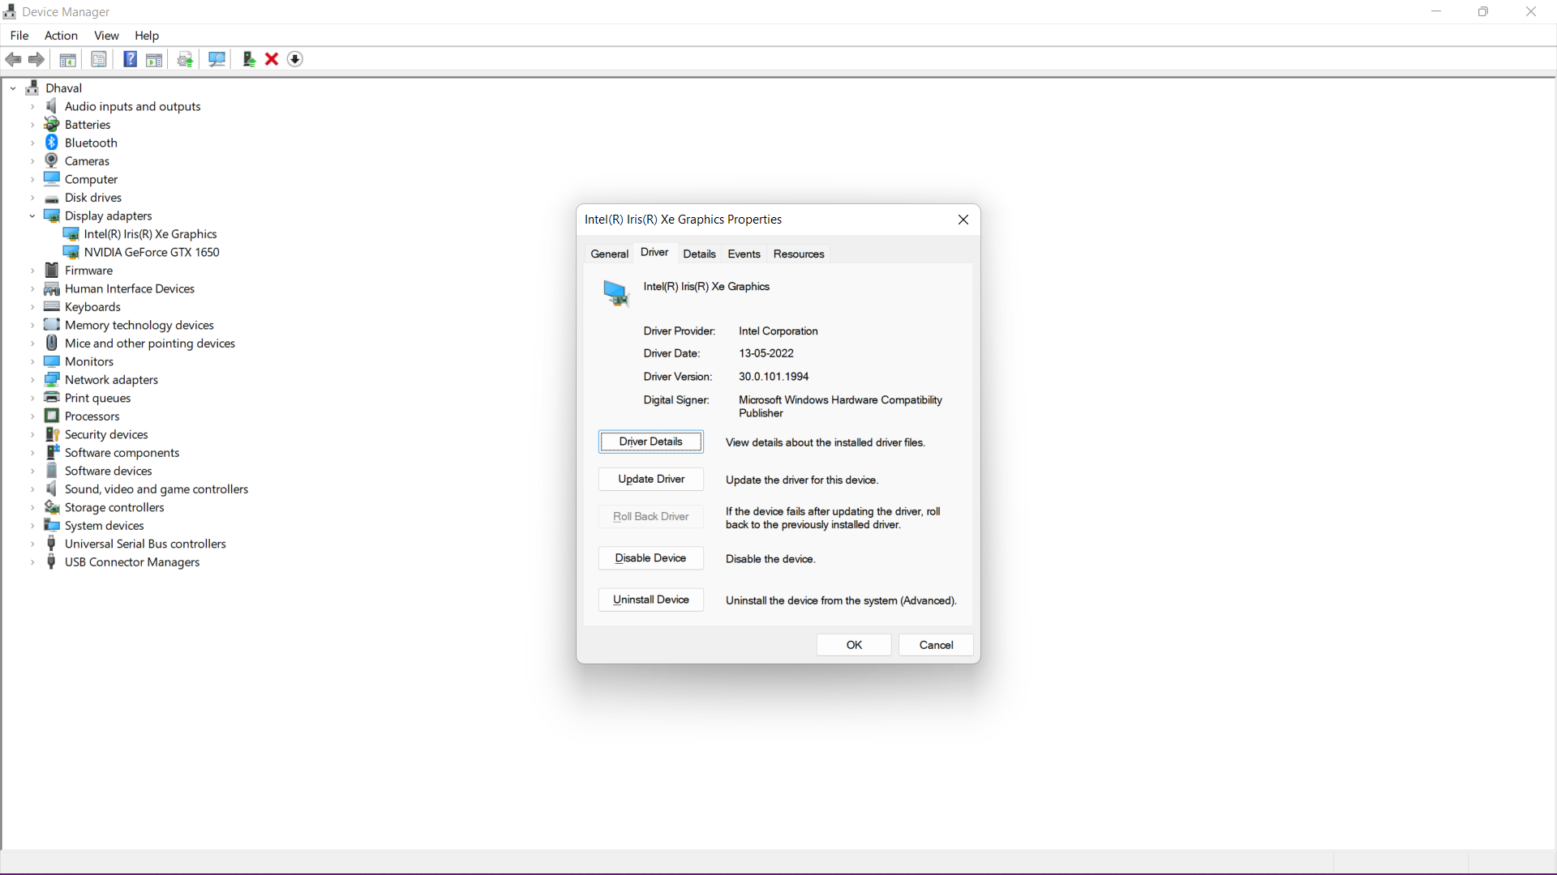

**Windows Access Controls**

Access control refers to security features that control who can access resources in the operating system. Applications call access control functions to set who can access specific resources or control access to resources provided by the application.

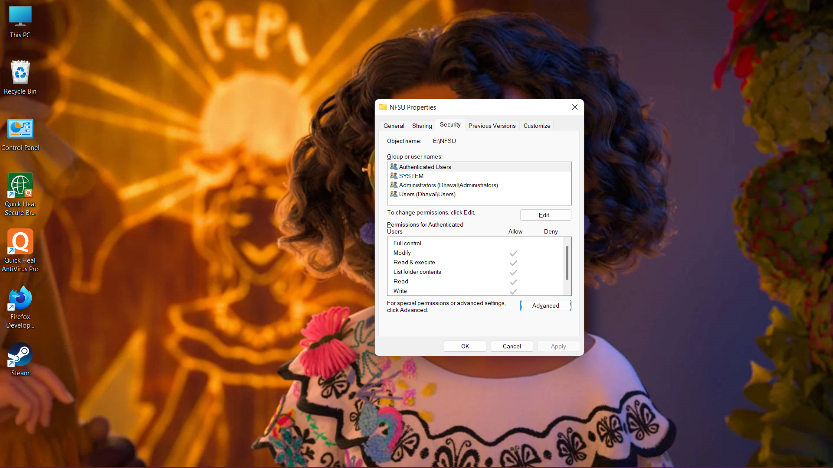

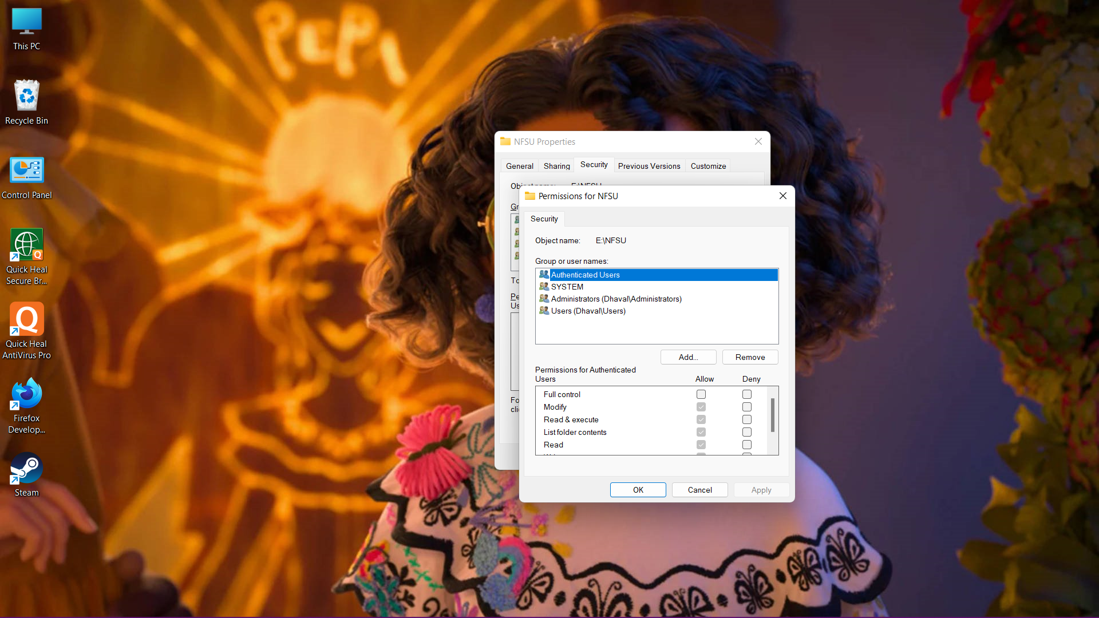

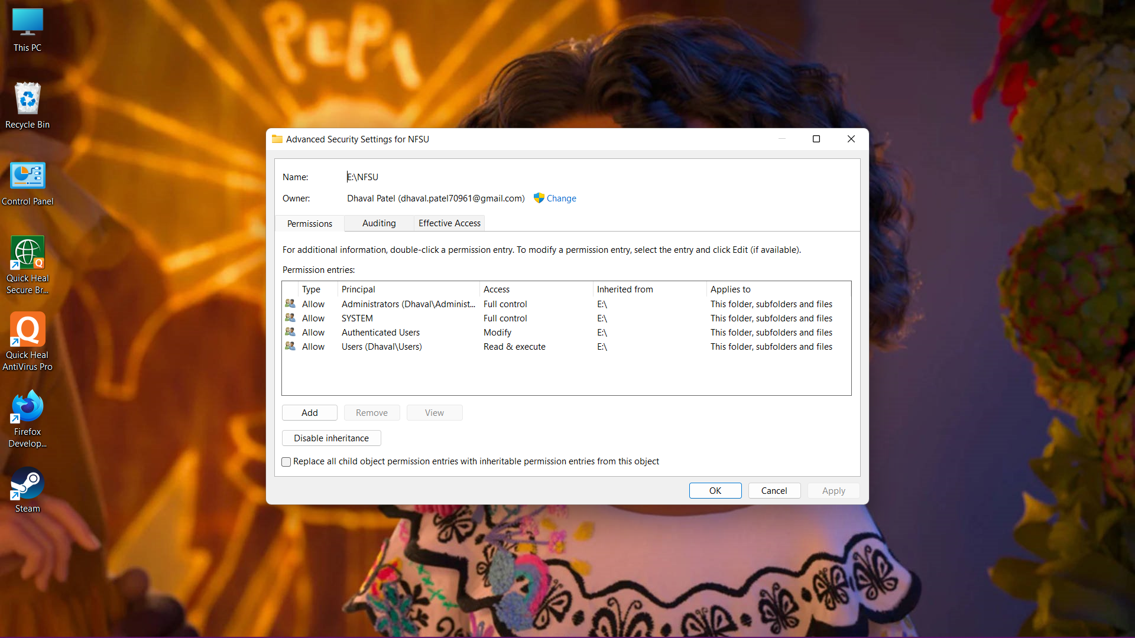 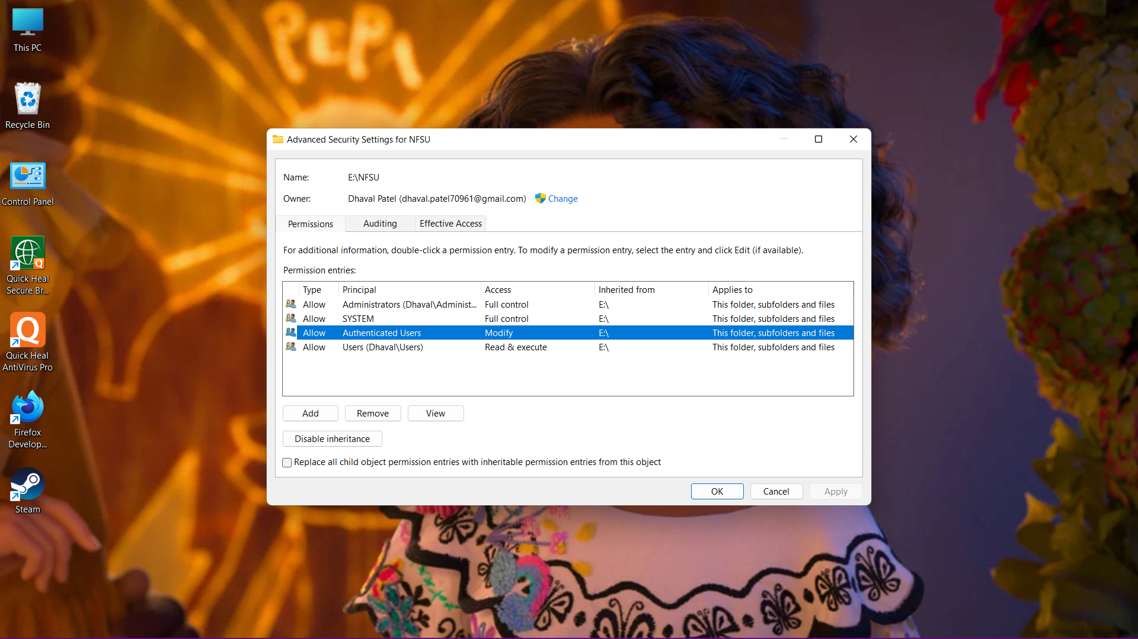

**NTFS Permissions:**

NTFS (NT File System) permissions are available to drives formatted with NTFS. The advantage with NTFS permissions is that they affect local users as well as network users and they are based on the permission granted to each individual user at the Windows logon, regardless of where the user is connecting.

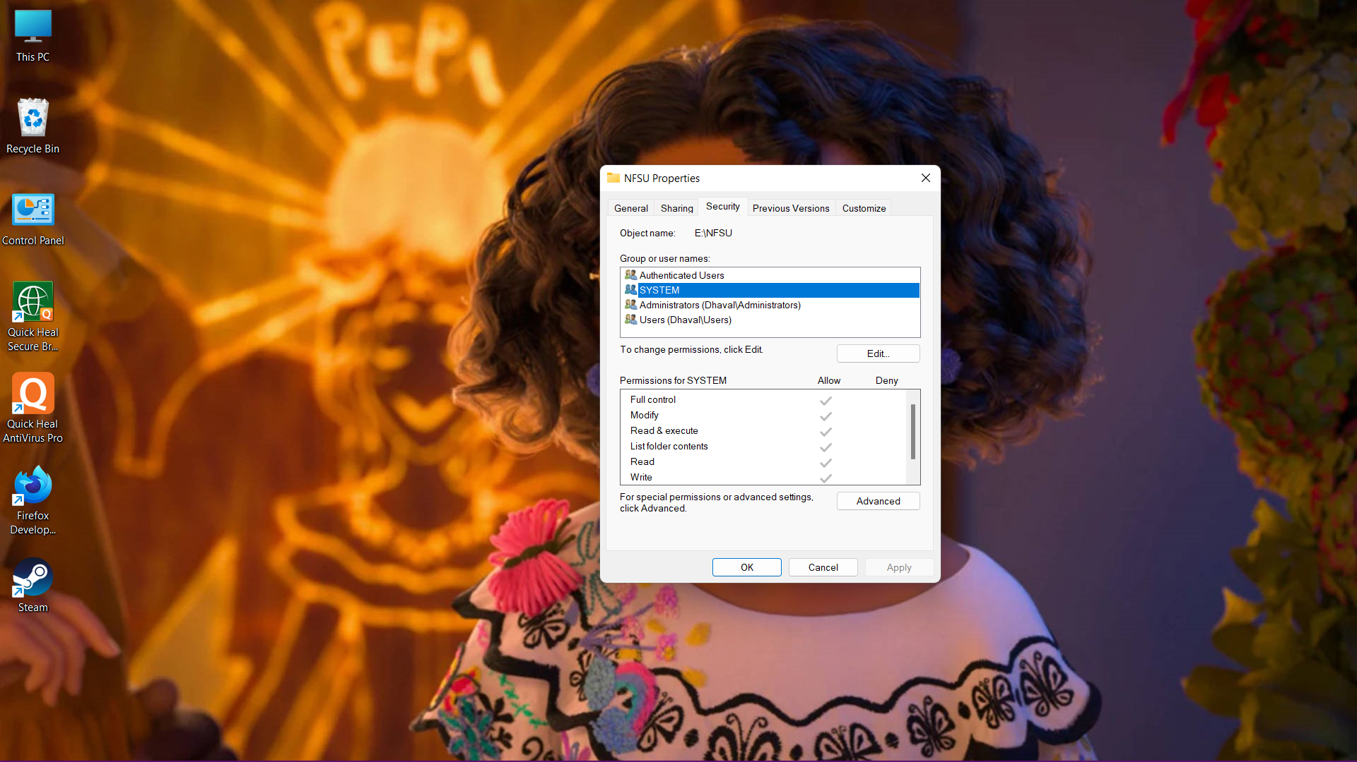

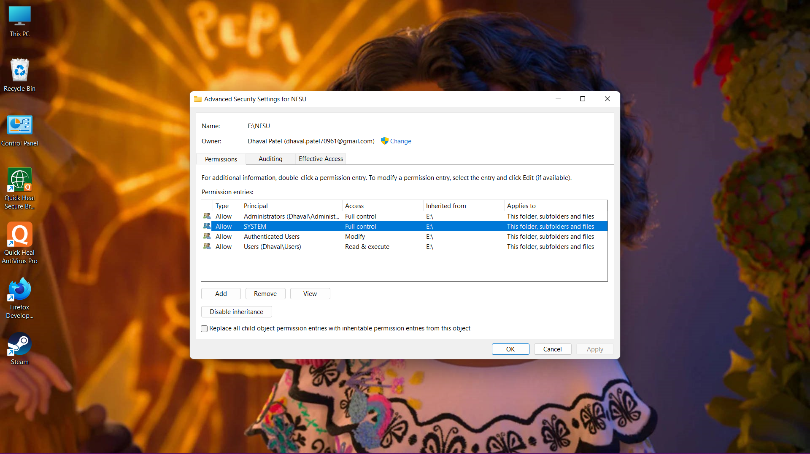

**Shared Folder Permissions**

share permissions allow you to control who accesses folders over the network (they will not apply to those users who are accessing locally). In share permissions, you cannot control access to individual subfolders or objects on a share.

